- What should you do if a shopper topples a pyramid of canned goods into the aisle?
  - Call for a custodian or maintenance person to clean it up
  - Pick up the cans & recreate the display yourself
  - Check on the shopper, & then erect a barrier around the cans, until they can be cleaned up properly

- What is the FIRST thing you should do if you find broken glass on the sales floor?
  - Call for a custodian or maintenance person to clean it up
  - Find a broom & clean it up yourself
  - Erect a barrier around the glass, or stand near the glass to direct traffic away from it until it can be cleared up

- Which of the following 3 actions must you personally witness an individual doing in order to take action against that customer for stealing?
  - Pick up the item, conceal the item & lie about having the item
  - Pick up the item, conceal the item, & leave the store without intending to pay for the item
  - Conceal the item, lie about having the item, & leave the store without intending to pay for the item
  - Conceal the item, leave the store without intending to pay for item, & get caught by the cameras

- Example of which one is not a perishable item:
  - Cosmetics
  - Over the counter medicine
  - Beverages
  - Socks

- Which form lists the quantity and type of merchandise that the vendor actually sent to your store?
  - Packing slip
  - Purchase order
  - Sales Invoice
  - Sales Receipt

- Which item shows a detailed list of items requested by the store?
  - Packing slip
  - Purchase order
  - Sales invoice
  - Sales receipt

- New merchandise arrives on your sales floor. Before re-stocking, you should
  - Check for damage first & then check that the price is accurate
  - Check that the price is accurate
  - Check if it is perishable & put the new stuff in front of the old
  - Check for damage & then put it on the shelf…someone will be desperate enough to buy the item

- Which display showcases the idea of suggestive selling?
  - A display with hunting gear and ballet slippers.
  - A display with a mannequin with a dress, necklace, & shoes on.
  - A display with different color watches.

- The purpose of tracking inventory is all of the following except
  - Make certain that the right merchandise is in the right store at the right time
  - Help verify the profitability of a store
  - Locate products that might have been damaged or dated items
  - Locate money that may have been misplaced
- It is best to show products:
  - In dim lighting to avoid glare
  - Under artificial lighting to improve color
  - In natural light
- A customer needs help on how to clean a jacket she just bought. What should you suggest for her to do?
  - Ask the manufacturer
  - Look at the label
  - Ask a customer
  - Ask an employee
- Private label items:
  - Are often made by famous manufacturers
  - May have the same features as a nationally-recognized brand
  - Are often less expensive than national brands
  - All of the above
- Permanent labels in clothing are required by law to include:
  - The city in which the product was made
  - The fiber content, in descending order
  - The size
  - All of the above
- When the sales associate is stocking the shelves, he should FIRST
  - Read the instructions on the manual to know how to use
  - Make sure the product is working
  - Practice saying the features and/or benefits to a co-worker

- Store Policies that are open to interpretation by store employees
  - Customer satisfaction
  - Government law
  - Safety
  - Liability of product
- Why is it important for employees to follow the same store guidelines?
  - To ensure same quality experience
  - To ensure all employees are paid the same
  - To ensure the boss has total control
- A hardware store has this sign displayed at its entrance (shown below). One day an associate sees a child bump into a shelf of industrial strength cleaners. A bottle falls off of the shelf and breaks. Its contents spill on the floor. The child runs to a parent in the next aisle, who doesn’t seem to notice what happened. Which of these should be the associates FIRST response?
  - Approach the child & ask open ended questions
  - Direct customers & employees away from the area
  - Calmly clean the spill according to the directions on one of the bottles still on the shelf
  - Let the parent know about the damage & tactfully ask for the payment according to the policy

- An associate has just begun a job at an office supply store. The associate has not seen any other employee use the copy machines for personal material, but knows that there are some benefits that haven’t been explained yet. The associate decides to bring in tax returns to photocopy. Which of these is the associate’s BEST court of action?
  - Wait until no one is around and copy the returns quickly
  - Ask a coworker what everyone else does, and then do the same
  - Consult store policy or the manager about using the copier
  - Copy the returns any time during the shift when there are no customers

- Use the following checklist to answer this question.
The owner of a deli tells an employee that a state health inspector will be visiting that day. The owner asks the employee to help prepare for the inspection. The owner writes out a list of the regulations that the health inspector will check (shown above). To help the deli pass inspection, the employee must make sure that

  - Every workspace is warm or cool enough
  - Employees keep their hair covered
  - Food waste is put in a can with a lid
  - The items in the display window are fresh

- A store manager asks a new associate to straighten stock on the display shelves. During a lunch hour rush, only one register is open, and the line of customers is growing. Some customers put down their selections and leave the store without buying. The associate has been trained on the register but hasn’t handled it alone. The manager is at lunch and cannot be consulted. Which of these is the associate’s best course of action.
  - Continue straightening the stock because this is the assignment the manager gave before leaving for lunch
  - Apologize to customers in line & tell them that the wait is usual & the manager will be back soon
  - Open another register, since the associate knows how to operative if even without having done it alone
  - Stop straightening stock & help the cashier by bagging, finding items, & getting the selections ready to be rung up

- A clothing shop has the sign clearly posted on the door. As associate is ringing up a customer & sees that another customer has a samll child who is eating a dripping icecream cone. The child is standing near a display of silk shirts. Which of these is the associates BEST response?
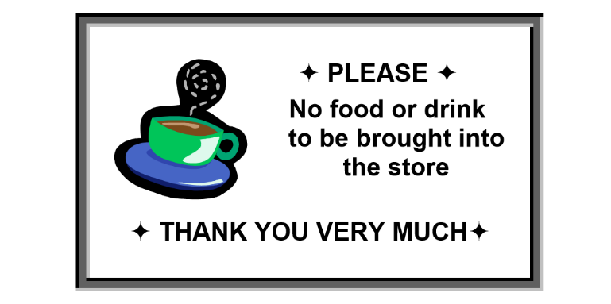
  - Briefly interrupt the first customer’s transaction, ask the second customer kindly to dispose of the ice cream, & offer to hold his selections
  - Finish ringing up the first customer, then politey explain to the second customer that he cannot be served until the ice cream is out of the store
  - Excuse herself from the first customer briefly & let the second customer know that he will have to pay for anything his child might damage
  - Call security or the store manager to deal with the situation, but warn the customer & give him some time to leave before they arrive.

- Use the page from the personnel policy below to answer the question that follows.
A cashier at the Pharmaid decides to buy a candy a bar to eat during break. According to the personnel policy shown, how should the cashier pay for the candy?

  - Ring up the candy himself before the break begins
  - Use another employee’s discount card to buy the candy
  - Ask someone else to ring up the candy after the break begins
  - Pay for the candy after the break is over

