Business of Retail Name ________________________
Chapter 4: The Retail Profit Model

- The Goodwill Thrift Store was working on their pricing strategy. They decided to end all of their prices in .97, a few cents less than the round number. So instead of selling a pair of pants at $15.00, they would sell them at 14.97. This is an example of
  - Competitive Pricing
  - Vendor Pricing
  - Psychological Pricing
  - Mark Down

- _____________ is the amount of money that comes into a retail business minus expenses.
  - Forecasting
  - Revenue
  - Margin
  - Reconciliation

- Courtney, the buyer for a small produce store and she sells 25 bags of oranges at $12 per bag. Her cost of goods sold per bag is $7. What is Courtney’s gross profit?
  - $293
  - $300
  - $175
  - $125

- Which of the following would you categorize as the COGs if operating a taco truck?
  - Cost of the meat, shells, and cheese.
  - Cost of the permit to operate the food truck.
  - Gas and maintenance costs.
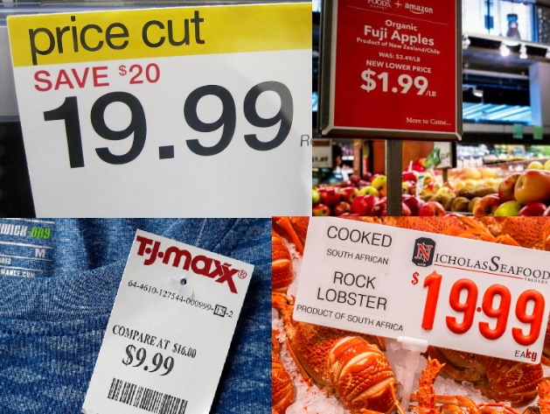
  - Your salary.

- The image to the right shows an example of which pricing strategy?
- Promotional pricing
- Psychological pricing
- Bundle pricing
- Discount pricing

- The “S” in MSRP stands for ______________.
- Store
- Standard
- Suggested
- Solution

- Jim is opening and operating a small online retail shop. What should he take into consideration when setting a retail price?
  - Customers’ price preferences
  - The amount of money you want to make on each item
  - The price set by the competitors on the same or similar products
  - The cost of products, website service fees, competitor’s prices, and the money you want to make on each item.

- Macey owns a clothing shop in which her current assortment includes summer apparel. It’s nearing end of summer so in order for her to make room for fall items, she decides to mark the items down in order to move them out of the store. What will happen to her gross profit if she does this?
  - Gross profit goes up
  - Gross profit goes down
  - Gross profit stays the same
  - Gross profit is unchanged

- If a store’s revenue is $3,050 and its cost of goods sold (COGS) is $1110, what is the business’s gross profit?
  - $400
  - $2500
  - $4160
  - $1940

- A store pays for a schoolbag $12 and sells it for $18. Since school has already begun and sales have slowed down, they need to markdown its price. What is the lowest they can mark down the backpack if they want to still make $3 in profit?
  - 66%
  - 1.66%
  - 16.7%
  - 16%

- Sam’s surf shop sold 11 surf boards over the weekend. Each beach ball costs $26.00. What’s the revenue for the surf boards?
  - $200
  - $370
  - $268
  - $286

- A business makes $5100 in daily revenue and on average, spends $1400 in the products sold and $2000 on employee salaries and other expenses. What’s the daily net profit of the business?
  - $1,700
  - $4,400
  - $1,500
  - $3,700

- A retailer factors in _________________ when considering utilities, marketing costs and real estate rental costs to their prices.
  - Unnecessary costs
  - Vendor costs
  - Manufacturing costs
  - Costs associated with retailing

- _____________ is the amount of money a retailer makes before taking expenses out or the difference between revenue and COGS.
  - Revenue
  - Net profit
  - Gross profit
  - Gross margin

