Chapter 4 – p 113
Verbal Cues vs Nonverbal (Body Language) Cues

 | Nonverbal | Verbal
Define
Example
Chapter 4- p 114-115
The Eight Primary Elements of Body Language
Match a circle from section 1 to section 2 to section 3.
Waving
Boredom
- Face
Avoid Visual Contact

Avoidance

2. Eyes
Long eye contact
Show Anger

Titling ones head
- Examples of Body Language
3. Posture
3. What could this body language mean?

Greeting
2. Eight Elements of Body Language

Slumping ones shoulders
Frustration
4.

Tapping ones foot
Sadness
5.

Folding ones arms
Acknowledgement

6.

8.
7.
Smiling
High Pitch voice
Moving away from the person
Interest
Confusion
Enthusiasm
Chapter 4- p 118
In Store, On the Phone, & Online
Rules of thumb for balancing these two groups

Chapter 4 – p 122
Customer Four Step Grievance Process

Chapter 4- p 130-132
Contacting Customers
Use a method suited to the customer & the situation
Type of Follow up?
Circle one
Follow up?
Circle one
Scenario

Type of Follow up?
Circle one
Follow up?
Circle one
Scenario

Type of Follow up?
Circle one
Follow up?
Circle one
Scenario

Type of Follow up?
Circle one

Follow up?
Circle one
Scenario

Type of Follow up?
Circle one

Follow up?
Circle one
Scenario

Type of Follow up?
Circle one
Follow up?
Circle one
Scenario

Chapter 4- p. 141
Calculate the Discount

- Suppose a footwear store has a few $105 basketball shoes that are just not selling. To get them to sell, the manager decided to mark them down by 30 percent. Discount in dollars? _______Discounted price? _
Please show your work!

- The golf pro shop was overstocked on starter sets of clubs. In order to move the $200 sets, a 20 percent discount is implemented. Discount in dollars? _______
Please show your work!

- If the buyer orders over $50, 000 of materials within a year, he may be given a 10% discount on his entire order. He orders $75,000 within the year. Discounted price? _
Please show your work!

4.1 Prepare for Selling
Sales Tax & Markup

- The manager at Gabriela's Furniture Store is trying to figure out how much to charge for a book shelf that just arrived. The book shelf was bought at a wholesale price of $147.00 and Gabriela's Furniture Store marks up all furniture by 60%. Markup in dollars? Sales price?
Please show your work!

- You buy a car for $20,000 & pay 5% in tax. Sale tax in dollars? Sales Price?
Please show your work!

- You buy a house for 400,000 dollars and pay a tax of 6%. Sales Price?
Please show your work!

- The list price of jeans is $100. There’s a 15% discount & the tax is 5%. Cost of calculator?
Please show your work!

Chapter 4- P150
Speaking to the customer

Matching
I’m enthusiastic about this subject
Monotone & flat voice

High pitch & drawn out speed

Abrupt speed & Loud tone

Slow speed & low pitch

High pitch & empathetic

Chapter 4 – P 151
Customers calling the store
Answer, Hold, Call Back

4.2 Gain Customer Commitment & Close the Sale
Coordinating Other Services to Expedite Delivery
Deliver Fee Schedule
Complete on your own for more practice

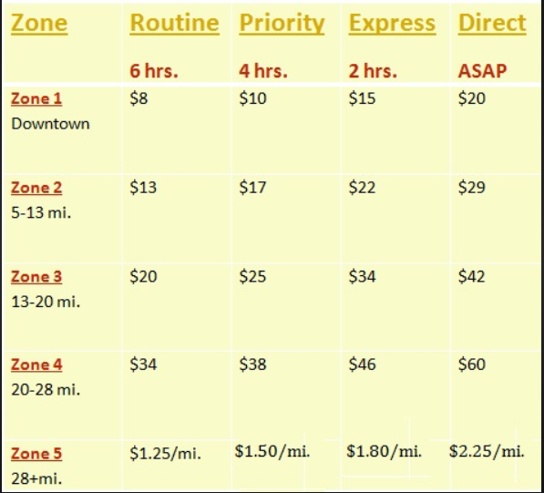

Answer the following questions:
- Which zone is the closest to the store?
- Which Delivery Type is the most expensive in all zones?
- How many miles can the delivery driver go before he must charge per mile instead of a flat fee?
- If the driver is delivering a priority item 22 miles away, what is the cost to do so?
  - Also, approximately how long will it take?

