Business of Retail Name ________________________
Chapter 2: Retail Operations

- What should the sale associate do first if he witnesses a customer’s child slip and fall causing the child to get a scratch on his elbow but appears to be otherwise unhurt?
  - Contact the company lawyer
  - Ask the parent if the child is okay
  - Call the paramedics
  - Notify the store manager

- Courtney has been a full time employee of a pet store for 2 1/2 years and she just had a baby. ________________ allows her to take unpaid, job-protected leave for specified family or medical reason.
  - Occupational Safety and Health Administration (OSHA)
  - Food and Drug Administration (FDA)
  - Fair Labor Standards Act (FLSA)
  - Family Medical Leave Act (FMLA)

- Its Easter time and the different size Easter baskets are heavily shopped. As you’re walking past, you notice some empty bins where certain sizes of baskets have all been heavily shopped. What’s the best next step?
  - Move some other sizes to the empty location so it doesn’t look as bare
  - Tell your co-worker to restock the Easter baskets
  - Leave the bins until the end of the night
  - Immediately check to see what size baskets are sold out, check the back room for additional items and restock the bins

- Chuck works in an electronics store is supposed to move large items from the storeroom to the store shelves. Chuck is able to move several large items at a time, but he is not using the back brace that he was trained to use when moving heavy objects. Is Chuck managing his responsibilities wisely?
  - No – Chuck could seriously injure himself by picking up heavy loads improperly.
  - No – It would probably be wiser for Chuck to transfer smaller armloads even though it would take him a bit longer and involve more trips to the storeroom.
  - Yes – By picking up large batches at a time, Chuck is working efficiently and getting the job done in a shorter period of time.
  - Yes – Chuck is the best judge of his ability to handle large loads.

- _______________ is the process of rotating perishable items that may expire so the newer items are in the back and the older items are in the front.
  - Stocking
  - Cross Selling
  - First In, First Out
  - Up selling

- A supermarket has about 50 1 gallon milk jugs that are close to their expiration date. What would you recommend as a sales associate?
  - Stop buying milk until all the eggs in stock are purchased.
  - Place the jugs with the nearest expiration date in the front.
  - Give a free jugs of milk to customers spending more than $50 in the store.
  - Create a sales promotion of “Buy 2 jugs of milk, get one free.”

- ____________ is the most common type of preventable loss.
- Employee theft
- Shoplifting
- Operational errors
- Vendor fraud
- A sales associate witnesses a customer slip on the floor and get back up immediately without any visible injuries. What should the sales associate do next?
- Write an incident report if the manager asks for one.
- Write an incident report only if 911 is called to the store.
- Write an incident report no matter how small the incident was.
- Write an incident report only if the customer complains about the incident.

- Which of the following does (OSHA) Occupational Safety and Health Administration not require employers to do?
- Inform employees of potential hazards
- Record all accidents or hazards
- Train employees how to respond when an accident occurs
- Encourage employees not to report accidents

- The inventory life cycle is disrupted when
- merchandise arrives on time
- supply equals demand
- merchandise is stolen or broken
- the customer has a clean, inviting environment to shop in

- The clear, acrylic shelf where the luggage is stores is chipped on the edge. Shelby, a customer, accidentally bumped her head into it when bending over to look at a piece of luggage. What kind of safety problem does this describe?
  - Slips, trips and falls
  - Struck-by injury
  - Workplace Violence
  - Whistleblower Act

- Which is not a proper safety technique when using a ladder?
  - Have a co-worker hold the ladder while you’re climbing to ensure it is stable
  - Maintain a three-point contact (two hands and a foot or two feet and one hand) whenever climbing up or down
  - Verify that the ladder is locked in position before use
  - Stand on the top step of the ladder

- Celine is a cashier at a shoe store. Stephanie, a customer at your register would like to buy a pair of shoes she has just tried on but now, but the electricity goes out in the store. With the power outage, your POS device is not working. What should you do?
  - You apologize to Celine and invite her to stay in the store to wait for the power to returns so you can then ring up her sales and also inform her that you must go lock the doors to prevent anyone else from entering.
  - You tell Celine that you must first lock the store and then you will take her name and phone number so you can call her immediately following power being restored. You then offer to ship the shoes to her home at no additional charge.
  - You inform Celine that you must close the store due to the power outage, and then you escort all customers, your fellow employees, and yourself out of the store while locking the doors behind you.
  - You apologize for the inconvenience, show Celine and other customers to the door informing them they must leave the premises, and then lock the doors behind them until the power is restored. You remain inside the store to await power return.

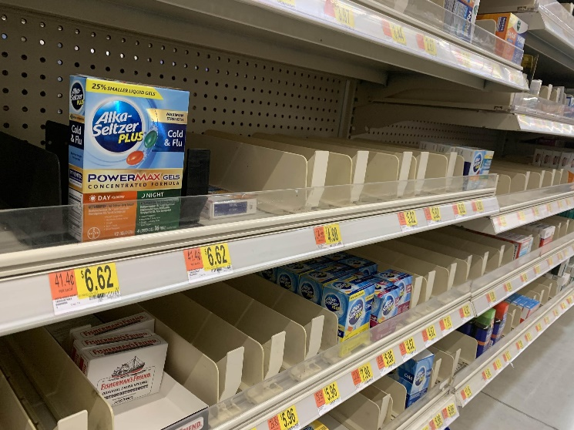
- You work in the pharmacy, and you find that one of the over-the-counter medicine shelves like the one depicted in the image are fairly empty. Why do you try to keep the shelves replenished? Select the best answer.
  - So I don’t get in trouble with the manager.
  - So I can be selected as the employee of the month.
  - So all the medicine in-stock can be sold quickly, before they go bad.
  - So there are enough options available for the customers to purchase at all times.

- What should a sales associate do if they find a product with the packaging broken on a shelf?
  - Move the item to the clearance section.
  - Move the item to the stockroom.
  - Leave it on the shelf hoping that a customer will buy it eventually.
  - Remove the item from the shelf immediately and take it to my manager.

