**Customer**

**Service**

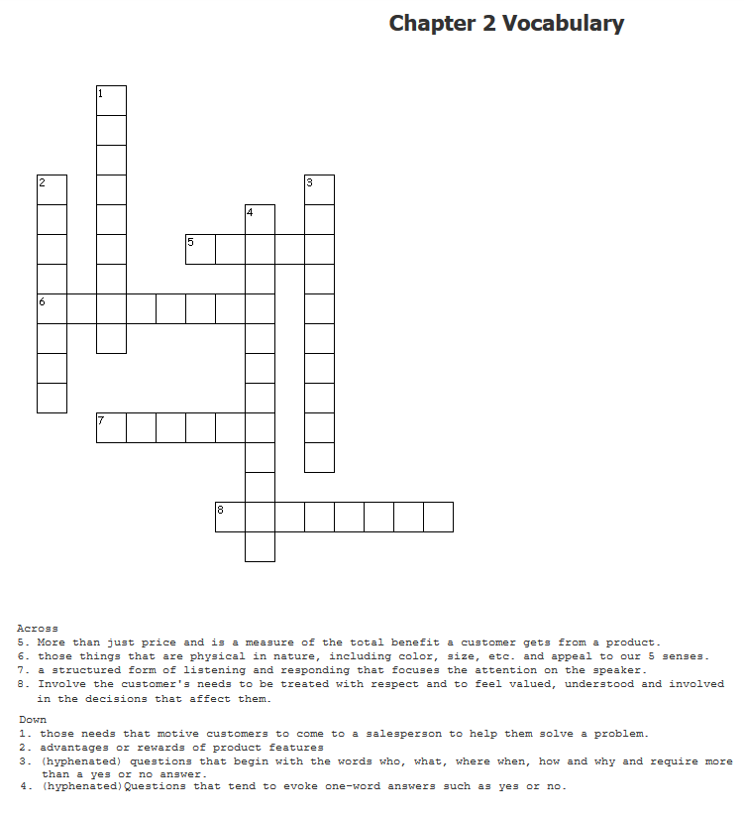

For hyphenated answers, you must write in the hyphen (-) as part of your puzzle answer.